**Introduction**

Out of 10 people, 8 have dreamed of making a career on YouTube.  
YouTube isn't just a platform — it's a global phenomenon shaping careers.  
In this project, we dive deep into the world's top YouTube creators.  
From global giants to national stars, we uncover the stories behind the numbers.

**Abstract**

This project analyzes the top YouTube creators globally and nationally based on their subscribers, video views, and other key metrics. Using Python(Numpy,Pandas,Matplotlib and Seaborn) for Extraction,Transform and Load (ETL).MySQL for data handling and Tableau for visualization, we uncover trends and patterns influencing digital content success. The goal is to provide insights into how YouTube creators grow and how data can drive strategic decisions in the creator economy.

**Tools Used**

**Python** : For Extraction,Transform and Load

**SQL** : Data Handling

**Tableau**: Visualization

**Steps Involved in Building the Project**

* **Data Collection**

Collect data from Kaggle and connected it to Python(Google Collab) via API Tokens.

* **Data Cleaning**

Handle Missing values , Duplicate Values , Data Types check and correction.

* **Filtering**

Loading of data in MySQL and filtering out necessary data

* **Visualization**

Then visualized data using Tableau.

**Insights**

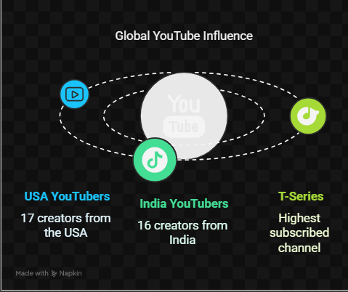

Among top 50 Youtubers,17 are from US and 16 are from India. Where as T-Series is the most subscribed channel globally as well as in India .

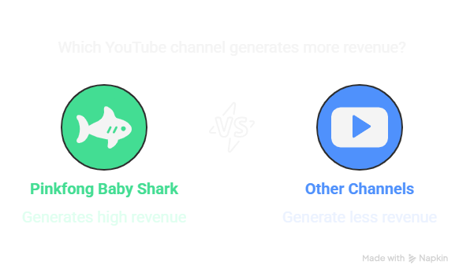 \

Pinkfong Baby Shark Youtube channel more money than others which shows Kids releated contents have more potential of earning more.

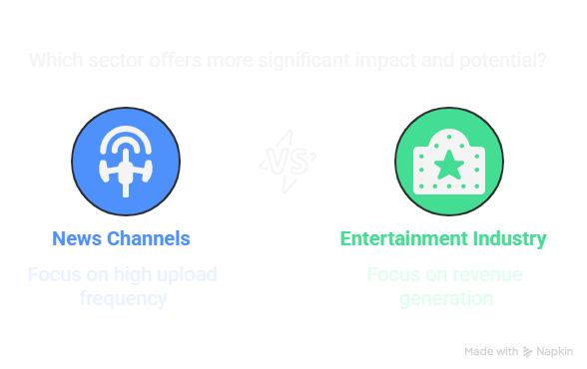

Entertainment Industry have high earning potential than News Channels.

**Conslusion**

* From the above analysis We can conclude few things:-
* More the country population,the channel will get more subscribers.
* Just gaining subscribers doesnot mean earning money as like Tseries and Pinkfong Baby Series.
* People love listening music in Youtube hence Music channels are in top in every list.
* Growth in Music channels declined but now are reviving.